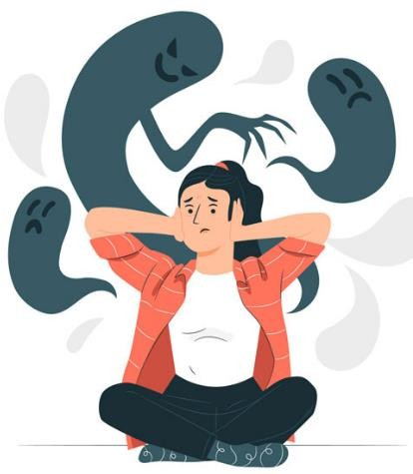
SCHIZOPHRENIA
Schizophrenia is a chronic severe mental disorder characterized by disturbances in thought, perception, emotions, behavior, and social functioning. It often involves delusions, hallucinations, and disorganized thinking.


Genetic factors – Family history increases risk.

Neurochemical imbalance – Mainly excess dopamine activity in the brain. Brain abnormalities – Structural and functional changes.

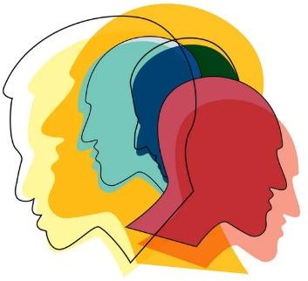
Environmental factors – Stress, trauma, infections during pregnancy. Psychosocial factors – Family conflict, social stress.


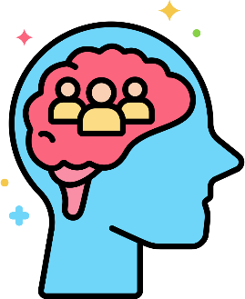
Paranoid type – Delusions of persecution or grandeur.

Disorganized (Hebephrenic) type – Disorganized speech and behavior.

Catatonic type – Motor disturbances (rigidity or excessive activity).

Undifferentiated type – Mixed symptoms.

Residual type – Mild symptoms after an acute episode.

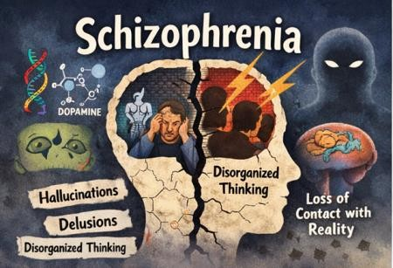
1. Pharmacological Treatment
Haloperidol
Chlorpromazine
Risperidone
Olanzapine
2. Psychotherapy
Cognitive behavioral
therapy (CBT)
Family therapy
Social skills training
3. Rehabilitation
Occupational
therapy
Community support programs

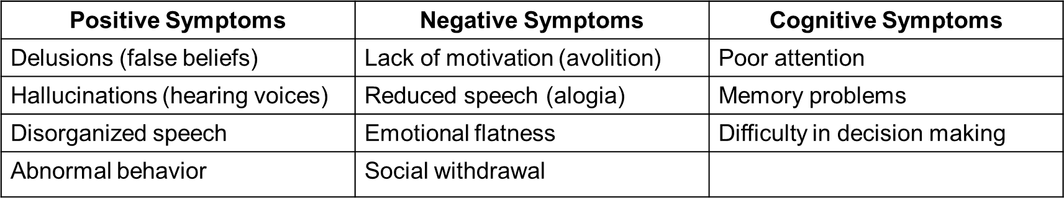
MANAGEMENT

