
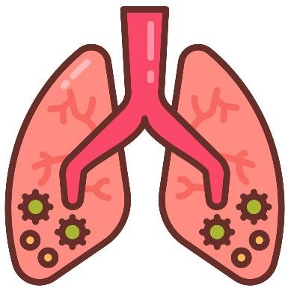

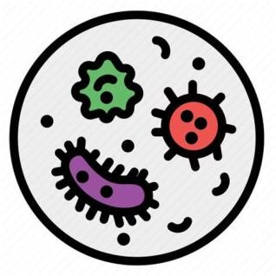
PNEUMONIA
Pneumonia is an infection of the lungs in which the alveoli (air sacs) become inflamed and filled with fluid or pus, leading to difficulty in breathing and reduced oxygen exchange.

CAUSES
Hospital-acquired infections
Aspiration – Inhalation of food, vomit, or liquids
Fungi – Histoplasma, Candida
Viruses – Influenza virus, RSV
Bacteria – Streptococcus pneumoniae (most common)

RISK FACTORS
Old age and young children
Smoking
Chronic diseases (COPD,
diabetes)
Weak immune system
Prolonged bed rest
Recent respiratory infection

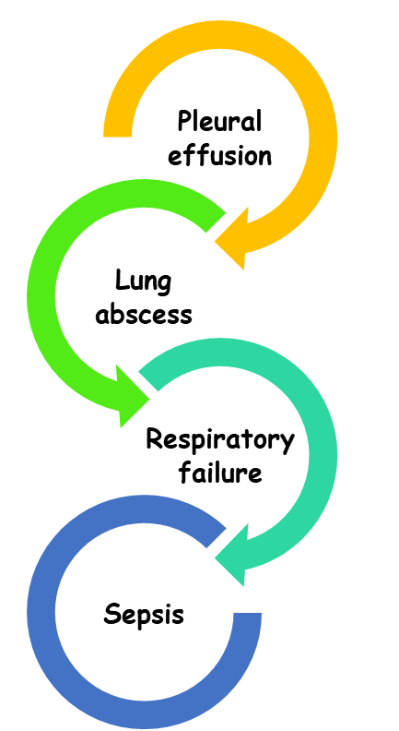
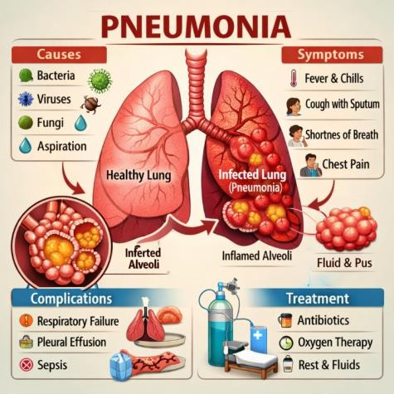
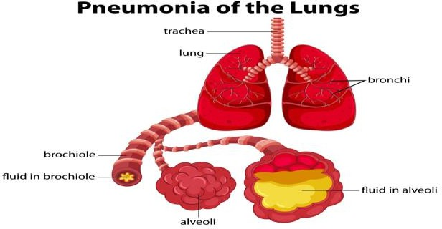
DIAGNOSTIC INVESTIGATIONS
Antibiotics – Amoxicillin, Azithromycin
Antiviral drugs (if viral)
Antipyretics – Paracetamol
Bronchodilators – Salbutamol
Oxygen therapy in severe cases
Adequate fluids and nutrition

MANAGEMENT

