


Diabetes Mellitus is a chronic metabolic disorder characterized by high blood glucose levels (hyperglycemia) due to defect in insulin secretion, insulin action, or both.

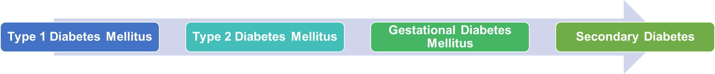

CLINICAL FEATURES (SYMPTOMS)
Classic “3 Ps”:
- Polyuria – Frequent urination

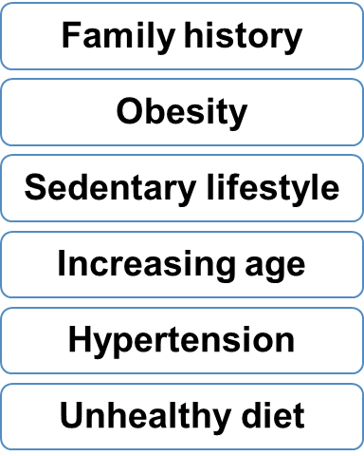
- Polydipsia – Excessive thirst
- Polyphagia – Increased hunger
Other symptoms

Recurrent infections

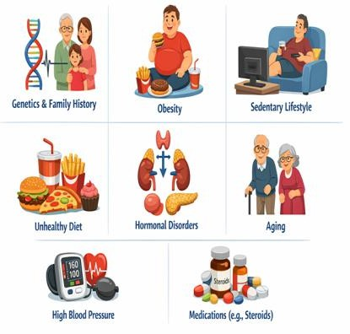
Fatigue | Weight loss | Blurred vision | Slow wound healing



Fasting Blood Glucose: ≥126 mg/dL
Postprandial Blood
Urine test: glucose

HbA1c: ≥6.5%

Glucose: ≥200 mg/dL and ketones


- Diet Therapy
  - Balanced diet
  - Low sugar intake
  - High fiber foods
  - Controlled carbohydrate intake

3. Medications

- Exercise
  - Regular physical activity
  - Helps improve insulin sensitivity

- Monitoring

  - Oral drugs: Metformin, Glibenclamide
  - Insulin therapy: Insulin injections
- Regular blood glucose monitoring
- HbA1c every 3–6 months

COMPLICATIONS
Cardiovascular diseases
Diabetic Retinopathy
Diabetic Nephropathy
Diabetic Neuropathy
Hypoglycemia
Diabetic Ketoacidosis

