

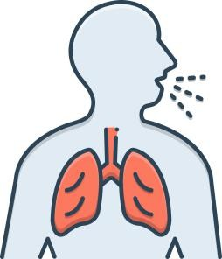
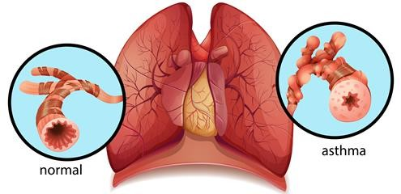
ASTHMA




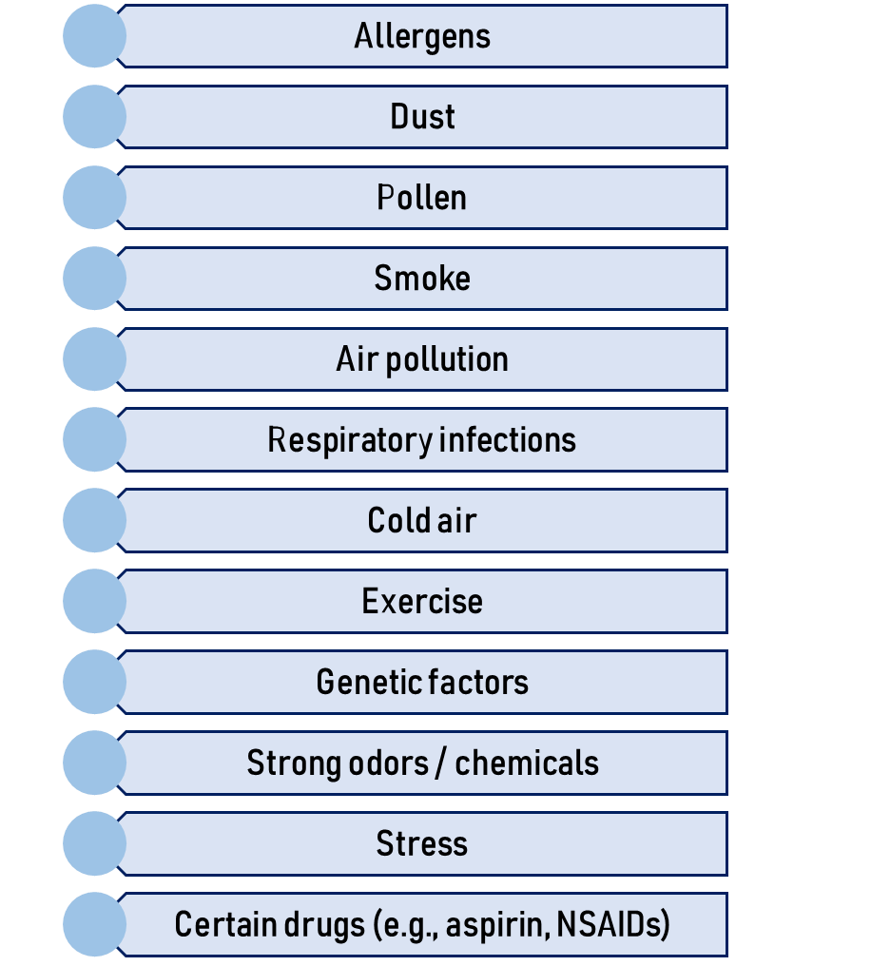
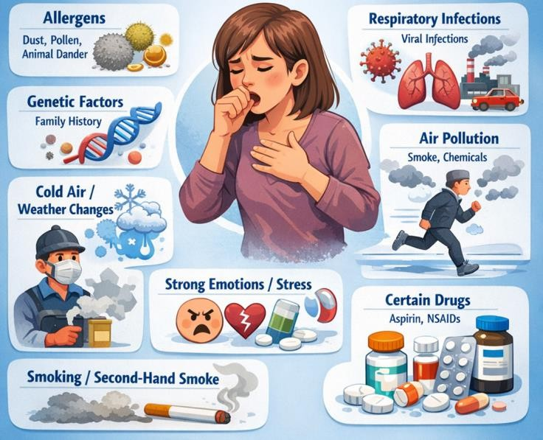


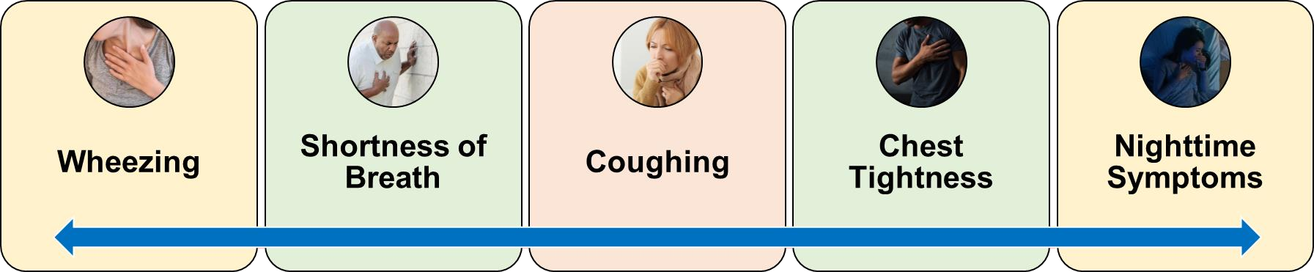
ASTHMA MANAGEMENT
- Bronchodilators

- Inhaled corticosteroids
- Leukotriene modifiers
- Anticholinergic drugs
- Oxygen therapy
- Nebulization
- Beta-2 agonists (Salbutamol)
- Oral corticosteroids
- Avoid allergens / triggers
- Breathing exercises
- Peak flow monitoring
- Patient education
- Use inhalers properly
- Avoid triggers (dust, pollen, pet dander)
- Monitor breathing
- Take prescribed medications

- Follow on asthma action plan

